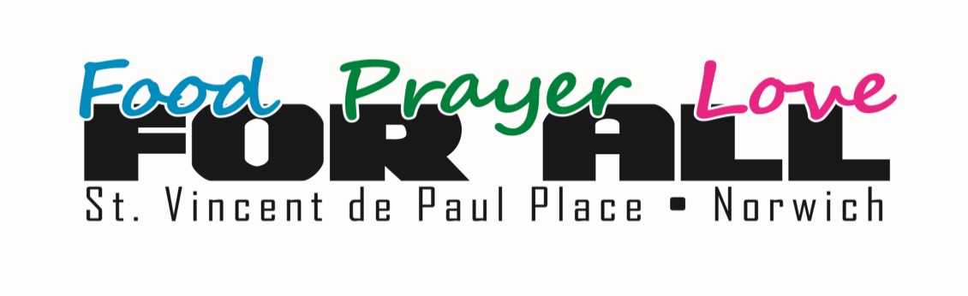

**Summary Report: January 1, 2018– June 30, 2018**

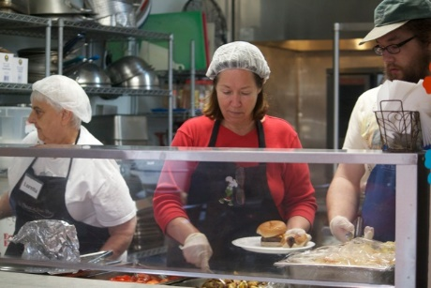

**Community Meals Program**

Our served meals program operated 156 days during the first 6 months of 2018, providing 34,243 breakfasts and mid-day main meals, an average of 219 meals per day. An additional 7,730 sandwiches and miscellaneous meals bring the total to almost 42,000 meals.

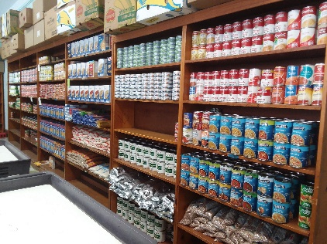

**Food Pantry Program**

During the same time period, our pantry distributed 235,326 meals to 1,074 unique households comprising 1,772 adults, 971 children, and 293 senior citizens.  They represented 21 towns and cities in Connecticut.  Counting each household member on each pantry visit yields 23,196 (duplicated) people who received food.

**Volunteers**

More than 150 active volunteers, community service workers, and Maturity Works participants provided 15,581 hours of service to the ministry during the period from January 1 to June 30. These volunteer hours equate to about 15 full-time staff members during this 6-month period. We celebrated everyone’s tireless efforts at our Annual Volunteer Appreciation Super Hero Picnic on June 24th. We thank our volunteers for ***Saving the Day***!

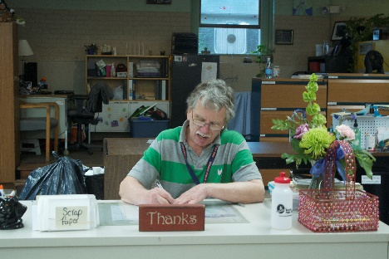 **Care and Advocacy Services**

At St. Vincent de Paul Place (SVdPP), care and advocacy encompasses a multitude of services, including pet food, hygiene, showers, shoes and clothing, apartment supplies, medical services, and haircuts. Our case manager meets with individuals to address difficult situations that arise and helps these individuals resolve their issues such as the loss of a job, health insurance, or a home. Other obstacles include employment issues, mental health challenges, domestic abuse, finding substance abuse treatment or adequate housing. **Services provided in the last 6 months include:**

**1412 Case management assessments**

**757 Unduplicated cases**

**127 New cases**

**22 Homeless intakes**

**23 People referred to detox/treatment**

**167 People received financial assistance**

**97 People received bus tickets**

**907 Showers**

**2722 Hygiene bags distributed**

**1689 Bags of pet food distributed**

**Showers**

SVdPP is the only agency in Norwich that is able to offer a public shower. Both men and women take advantage of this service on a daily basis. Currently, we have one shower stall located in the men’s bathroom, which we shut down to men when women are using the shower. The juggling act between which bathroom men and women can use during shower times will soon be over. Thanks to a generous donor, we are in the process of installing a shower in the women’s bathroom that should be up and running by the end of July. Since January, we have averaged 127 showers per month and increased that number to 237 per month since May.

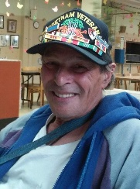**Memorial Services**

Saying good-bye to people we care about can be difficult. At SVdPP, we provide memorial services for patrons we lose who might otherwise not have a funeral or memorial service. This year we lost three very special members of our community, two of whom were veterans.

Pictured: Irwin Joseph Rutchik, decorated Vietnam Veteran.

**Community Partnership: Medical Services**

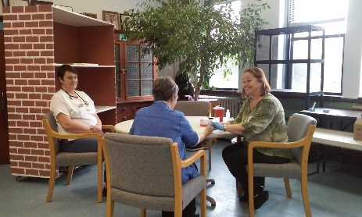**Three Rivers Nursing Students** came to SVdPP once a month from January to April to participate in a wellness clinic. During these visits, they were able to provide blood pressure checks and glucose monitoring while answering general medical questions.

**Generations Family Health Care** continued to provide services on the Backus medical van in our parking lot on Monday mornings from 9:00-11:00 am and Rapid HIV testing in the dining room during lunch once a month.

**Backus Hospital Sexually Transmitted Disease Clinic** provided a 1-day Hepatitis C clinic in February.

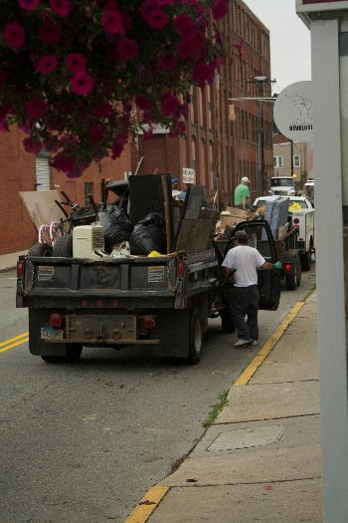

**Community Partnership: Norwich Clean-Ups**

We are in the 5th year of cleaning the streets of Norwich in partnership with Reliance Health and local churches. Our goal is to reach a 5-year total of 100,000 pounds of garbage collected by the time we end our season in September of this year. We are currently at 90,743 pounds, well on our way to our goal. Clean-ups are held once a month from 9:00-11:00 am in different areas of Norwich.

**2014 12,960 lbs. 2018: March Brush** Ellis Ruley Memorial Park

**2015 16,760 lbs. April 2,980 lbs.** Lake Street

**2016 26,943 lbs. May 1,040 lbs.** Indian Leap

**2017 25,320 lbs. June 4,740 lbs.** Rose Arts Festival Route

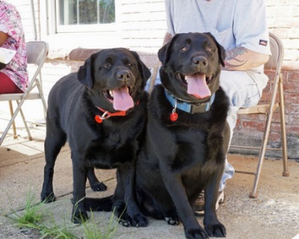**Community Partnership: Norwich Pet Wellness Clinics**

This is the last year of a three-year pilot program, funded by the Community Foundation of Eastern CT. This funding has allowed the Connecticut Humane Society to collaborate with SVdPP, Norwich Human Services, Norwich City Clerk’s office, Norwich Animal Control, and Norwich Community Policing Unit to provide pet wellness clinics to low income households. The last pet clinic will be in August.